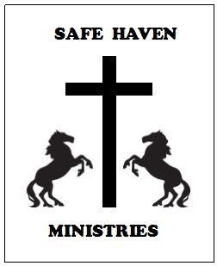

GEAR UP – Armor of God Camp Registration
Boys and Girls - Tuesdays, 6:00-8:00 pm; (6 sessions)
Grades 6-8 June 1 – July 6 (Rising) Grades 4-6 (Rising) July 20 – August 24 Grades 1-3 September 7 – October 12 – 6:00 – 7:30 pm

PARTICIPANT’S NAME: ___________________________________________

AGE _____ Grade in Fall __________ Height ________ Weight ________ Girl_____ Boy ______

Guardian Name(s): ____________________________________________________

Email: _____________________________________________________________

Street Address________________________________________________________________

City, ____________________________________ State, ________ Zip _______________

Home Phone: (_____)________________ Cell Phone: (_____)_________________________

Emergency Contact Name and Phone: _______________________________________________
Does child have an allergy or physical condition which we should be aware of? Y N If yes, explain:
_________________________________________________________________________
Other concerns? Y N If yes, explain:

___________________________________________________________________________

Photo Release: Parent/Guardian grants Safe Haven Ministries permission to take still and moving films of above named participant and authorizes Safe Haven Ministry to use and reproduce the photographs, and pictures to promote their ministry. Yes _____ No ______

Registrations may be screen shot and sent to: safehaven.kc@gmail.com or mailed to
Cheryl Schweizer, 18960 Dillie Rd., Edgerton, KS 66021

Guardian Signature____________________________________________________

